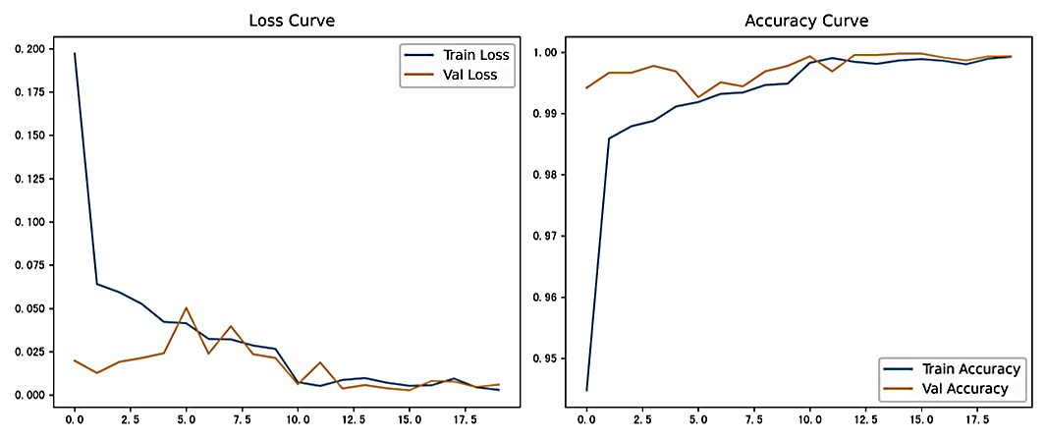
Figure 4.1 Training Curves

